Static route project 2

Ping from PC1 TO PC2 & PC3

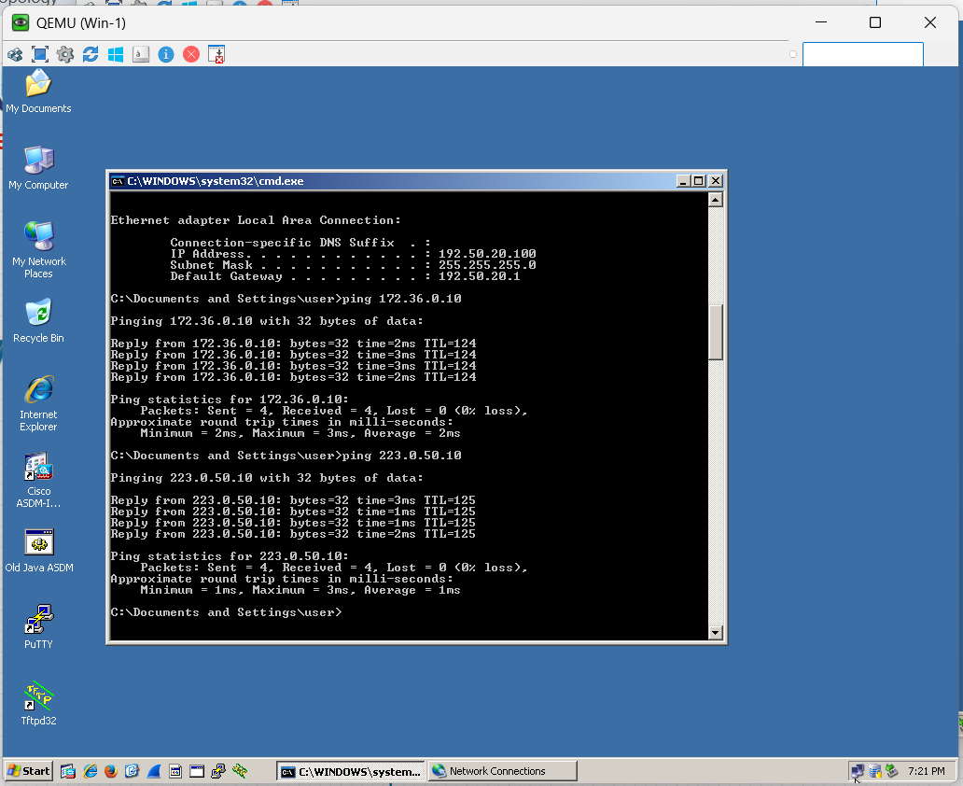

Ping from PC2 TO PC1 & PC3

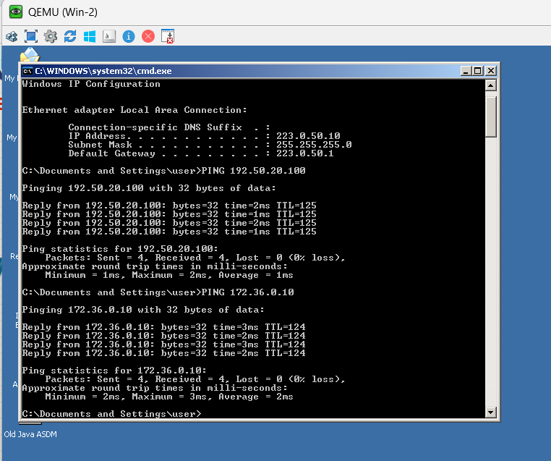

Ping from PC3 to PC1 & PC2

